ICE BOCCE RULES
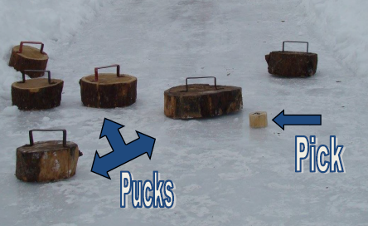
The object of the game is to slide your Ice Bocce Pucks closer to the Pick than the opposing team.
Playing Ice Bocce:
The games consists of 6 frames (down and back 3 times.) A frame starts with kicking the Pick by a team member toward the opposite end of the lane. The frame is complete after the Pucks have been slid and the points awarded.
Whoever wins the coin toss (using the Pick) will begin. If the Pick is kicked out of the lane on the opening kick-off it will be re-kicked. Pick must land past the half way line.
Once the Pick is in position, the first team slides their Puck. Taking alternate turns, each team slides their Pucks toward the Pick to get their Puck closest to the Pick. You must release the Puck handle immediately once the Puck is on the ground.
No steps can be taken beyond the hole when tossing the Puck. Pucks must be released before 10 foot line.
If the Puck is not lying flat or has any part off of the lane it will be removed from play. If the Puck goes in the hole it is in pay regardless if it is lying flat or not.
In the event the Pick is kicked out of play during the match, it will be dropped into the hole at the end of the lane being played and the remaining pucks will aim closest to the hole.
If the Pick is knocked out of play when a Puck is already in the hole the Puck will be picked up and the Pick will be dropped in the hole. The Puck should then be placed back in the hold the same way it was.
Scoring:
In each frame, only one team scores. One point is given for each Puck that is closer to the Pick than the opposing team’s Pucks.
To break a tie, one additional frame will be played.
Tournament:
Bracket system will be “Pool Play” with teams divided into groups of 4 teams. Each group of 4 teams will be assigned two lanes to play on.
Each team will play 3 games in the 4 team bracket they are placed in.
Determine a team captain who will be responsible for turning in the team score after each game.
The top 32 teams (2 best from each pool) will advance to the tournament bracket to determine the top 4 teams.
Disputes that cannot be resolved by the two teams’ captains will be decided by the judge. Judges decisions are final!
If a team does not show up for their tame in a timely manner they will forfeit the match.

